Schreibt man diese Wörter mit chs, x oder ks?
chs – x oder ks?
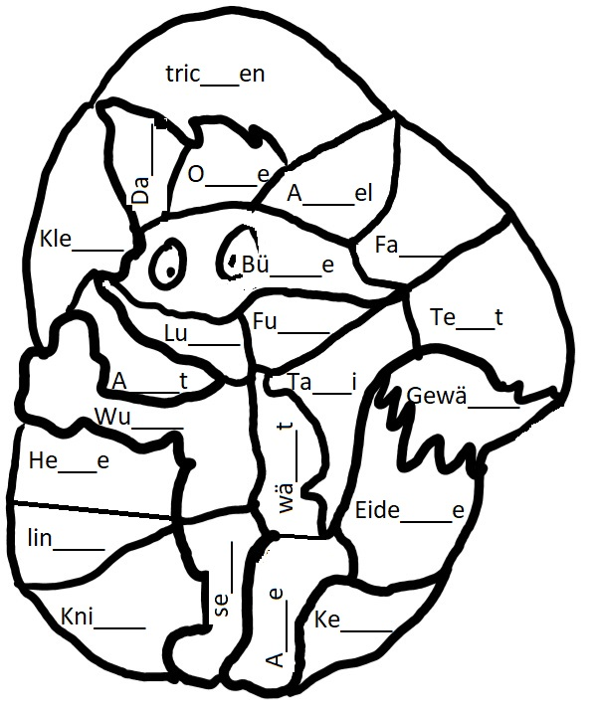
- Ergänze die fehlenden Buchstaben.
- Male alle chs-Teile braun au, alle x- und ks-Teile grün.

Die Eidechse verwandelt die Hexe in einen Fuchs!

chs – x - ks
- Schreibe mit jedem Wort einen Satz.
- Markiere chs, x oder ks jeweils rot.
- Es dürfen gerne lustige Sätze sein.

_______________________________________________________________________________________________________________________________________________________________________________________________________________________________________________________________________________________________________________________________________________________________________________________________________________________________________________________________________________________________________________________________________________________________________________________________________________________________________________________________________________________________________________________________________________________________________________________________________________________________________________________________________________________________________________________________________________________________________________________________________________________________________________________________________________________________________________________________________________________________________________________________________________________________________________________________________________________________________________________________________________________________________________________________________________________________________________________________________________________________________________________________________________________________________________________
_____________________________________________________
____________________________________________________
___________________________________________________

Lösungen

Luchs Ochse Wachs Dachs Büchse Wuchs Achse sechs wächst Achsel Gewächs Eidechse
Keks, Klecks, links Knicks tricksen
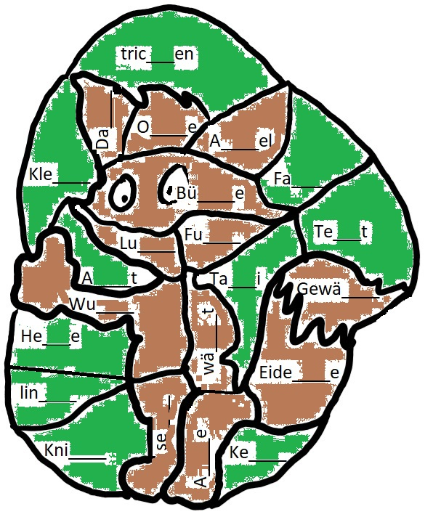
Fax Text Axt Hexe Taxi

