Ein Bild, das Cartoon, Clipart, Säugetier, Animierter Cartoon enthält.

**Oster-Rätsel**

|  |  |  |  |  |  |  |  |  |  |  |  |  |  |
| --- | --- | --- | --- | --- | --- | --- | --- | --- | --- | --- | --- | --- | --- |
| V | O | D | D | E | K | C | L | N | F | V | A | O | L |
| Ä | S | Ö | P | K | G | G | X | P | E | E | U | S | P |
| Y | T | M | W | H | H | V | D | Q | S | R | F | T | R |
| U | E | K | A | N | L | U | W | W | T | R | E | E | E |
| K | R | E | U | Z | I | G | U | N | G | A | R | R | L |
| P | N | S | A | L | B | U | N | G | D | T | S | N | I |
| G | R | Ü | N | D | O | N | N | E | R | S | T | A | G |
| T | J | E | S | U | S | Y | U | I | B | T | E | C | I |
| J | U | D | A | S | U | Q | X | S | S | Q | H | H | O |
| K | A | R | F | R | E | I | T | A | G | M | U | T | N |
| A | B | E | N | D | M | A | H | L | P | K | N | C | J |
| G | L | A | U | B | E | Ö | C | N | N | R | G | G | R |

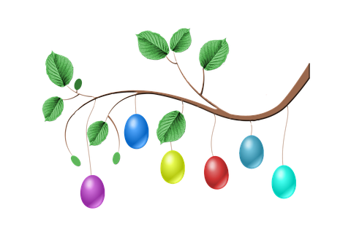

In diesem Suchrätsel sind 14 Wörter versteckt, die zum Osterfest passen. Suche und markiere sie.

Ostern - Kreuzigung - Jesus - Auferstehung - Glaube - Fest - Osternacht Gründonnerstag - Karfreitag - Salbung - Abendmahl - Verrat - Judas - Religion

Duplikat ohne Füllbuchstaben:

|  |  |  |  |  |  |  |  |  |  |  |  |  |  |
| --- | --- | --- | --- | --- | --- | --- | --- | --- | --- | --- | --- | --- | --- |
|  | O |  |  |  |  |  |  |  | F | V | A | O |  |
|  | S |  |  |  |  |  |  |  | E | E | U | S |  |
|  | T |  |  |  |  |  |  |  | S | R | F | T | R |
|  | E |  |  |  |  |  |  |  | T | R | E | E | E |
| K | R | E | U | Z | I | G | U | N | G | A | R | R | L |
|  | N | S | A | L | B | U | N | G |  | T | S | N | I |
| G | R | Ü | N | D | O | N | N | E | R | S | T | A | G |
|  | J | E | S | U | S |  |  |  |  |  | E | C | I |
| J | U | D | A | S |  |  |  |  |  |  | H | H | O |
| K | A | R | F | R | E | I | T | A | G |  | U | T | N |
| A | B | E | N | D | M | A | H | L |  |  | N |  |  |
| G | L | A | U | B | E |  |  |  |  |  | G |  |  |